Amazon Sales Data Analysis Report
Peiris K.N.W | 21020736 | 2021/IS/073

- Introduction
In this assignment, we analyze an Amazon sales dataset to understand business performance and identify important patterns. The main goal is to explore sales trends, customer payment behavior, and price distribution. This analysis helps the company understand how products perform, which payment methods customers prefer, and how pricing affects total sales. The findings can support better business decisions and improve sales strategies.

- Data Analytics Methodology
The data set used for this analysis contains 10,000 sales records and 21 features such as product category, price, quantity, discount, shipping cost, total sales, and payment method. Before analysis, the dataset was checked for missing values and data consistency. Basic data cleaning and preprocessing were performed using Python. Then exploratory data analysis and visualization techniques were applied to identify patterns and relationships in the data.

03. Exploratory Data Analysis (EDA)

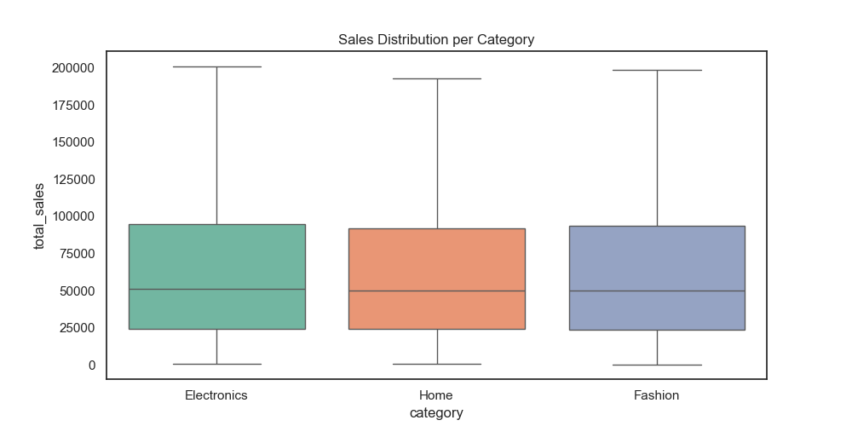
Figure 1: Sales Distribution Boxplot
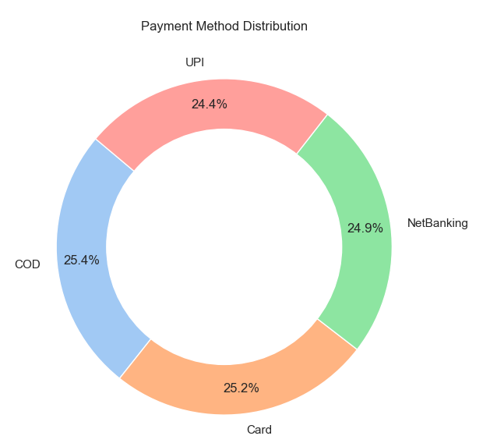
Figure 2: Payment Method Distribution
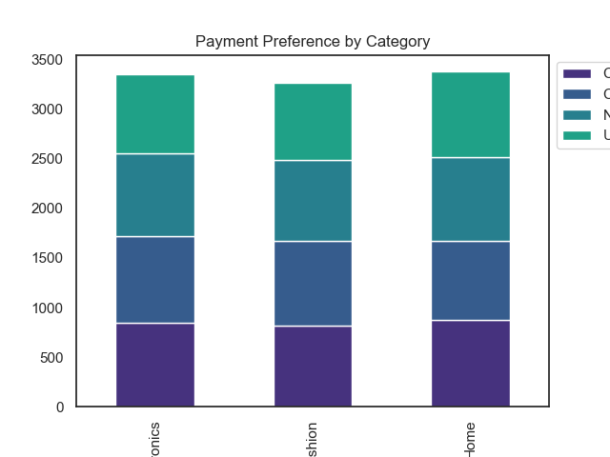
Figure 3: Payment Method by Category
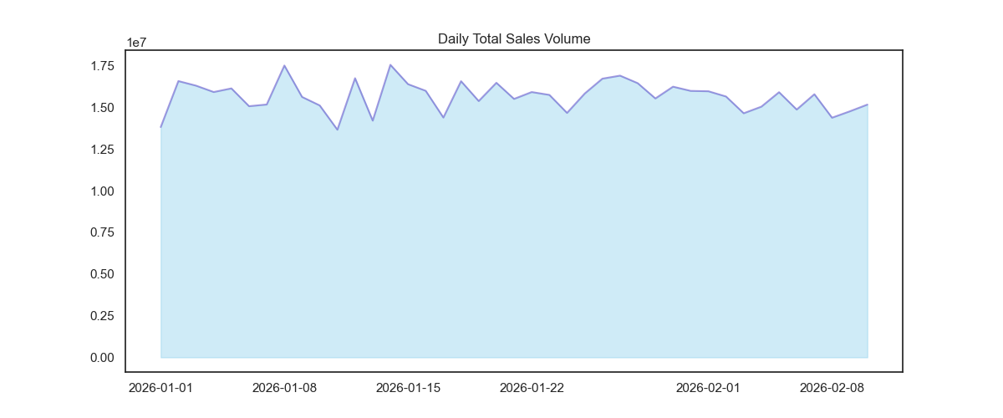
Figure 4: Sales Trend Analysis
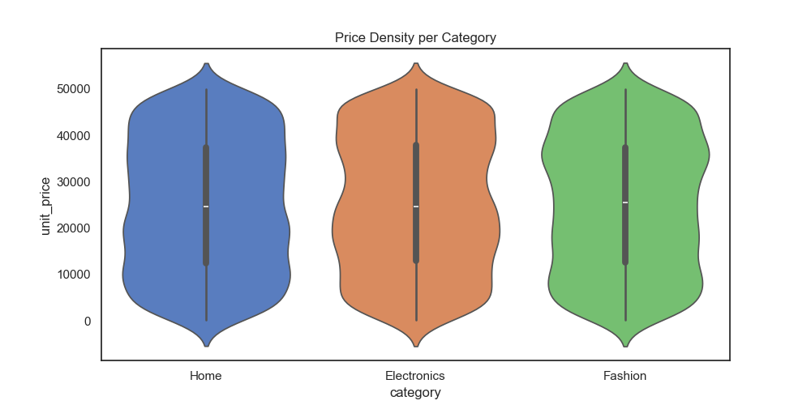
Figure 5: Price Distribution by Category

- Key Findings
The analysis shows that sales values vary widely, indicating different product price ranges. Some products generate very high sales compared to others. Customers use multiple payment methods, but some methods are more popular than others. Understanding customer payment preference can help improve customer experience. Sales trends show changes over time, which can help businesses plan future marketing and inventory strategies. Price distribution analysis shows that different product categories have different pricing patterns.

- Business Recommendations
1. Focus on high performing products to increase revenue.
2. Improve support for popular payment methods to enhance customer satisfaction.
3. Monitor sales trends regularly to plan inventory and promotions.
4. Review pricing strategies across categories to remain competitive in the market.

- Conclusion
This analysis provided useful insights into sales performance, customer behavior, and pricing patterns. By using data-driven decisions, the company can improve sales performance, customer satisfaction, and business growth.

